Envir. Tech: React 15.6, Redux, Immutable.js, Bootstrap?

Middleware:

Ebook: Learning Web Development with React and Bootstrap

Build real-time responsive web apps using React and Bootstrap:

TODO real-time examples:

* Hello World! with ReactJS
* A simple static form application with React and Bootstrap

Fin Ebook

20180411:

GIT :

$ git checkout develop

$ git stash

$ git checkout develop

$

$ git checkout -b develop-maps

React 16.0:

20180410:

https://www.reactboilerplate.com/

20180409:

Sécurité avec Keyloack?

Projet react : front-poc

the entry file for the application : app.js

// Create redux store with history

redux : state management ? variables

// Import root app

import App from 'containers/App';

constants.js index.js selectors.js

stateless functional component (SFC) ?

Projet react-google-maps ? React 16.1.0

RDVContainer/index.js

import './index.css'

TODO loaded:

SignUpContainer/index.js

render() {

return (

<SignUpContainer

products={this.props.products}

cities={this.props.cities}

onSubmit={this.props.registerClientAction}

getCityAgences={this.getCityAgences}

/>

);

}

componentDidMount() {

let map = new window.google.maps.Map(document.getElementById('map'), {

center: {lat: -33.8688, lng: 151.2195},

zoom: 13,

mapTypeId: 'roadmap',

});

}

<div id='map' />

SelectField

DatePicker

TextField

TODO containers/SignUpContainer

DONE containers/SignUpPage/index.js

//this.props.getCityAgences(cityId);

Par this.getCityAgences(cityId);

TODO React-Bootstrap Vs Twitter Bootstrap

ReactJS-JSX :

JSX tags have tag names, attributes, and children

**render: function () {**

**return React.DOM.div({className:"divider"},**

**"Label Text",**

**React.DOM.hr()**

**);**

**}**

To JSX syntax:

**render: function () {**

**return <div className="divider">**

**Label Text<hr />**

**</div>;**

**}**

TODO

ReactJS+ Redux :

Utilisation de Redux-saga:

<https://scotch.io/tutorials/build-a-media-library-with-react-redux-and-redux-saga-part-1>

* [**React**](https://facebook.github.io/react/): core infrastructure
* [**Redux**](http://redux.js.org/): state management
* [**Redux-saga**](https://github.com/yelouafi/redux-saga): demystifying asynchronous processes

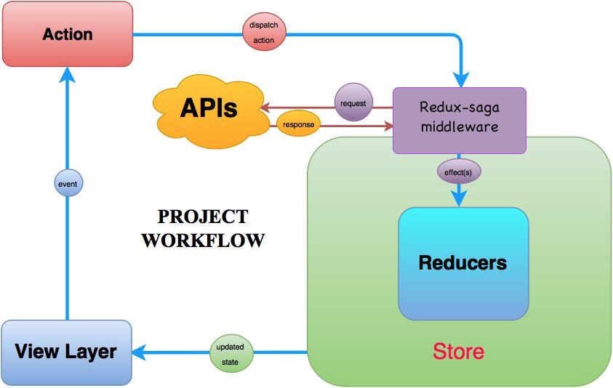

TODO Workflow:

1. **View layer** is our React component. It makes a request for action based on interactions on/with the application.
2. **Action**, commonly called action creator returns a formatted object of the action type and optional payload which is then dispatched to the store.
3. **Redux-saga** is a Redux middleware for handling async operations like fetching photos and videos from our API. It makes asynchronous operations look like standard Javascript synchronous code making it easy to read, test, and reason.
4. **APIs** are resource locations to fetch photos and videos in our own case.
5. **Reducers** are simply pure functions whose purpose in life is to accept the state tree and an action from the store; make a copy of the previous state, transform it and then return a new state to the store.
6. **Store** is a single object that holds the complete state of your application. It delegates the reducer with the responsibility of changing state when an action is dispatched.

When the store receives an updated state, it transmits to the view layer to be rerendered.

# Reducers

**Learning Web Development with React and Bootstrap Pdf**



TODO à fusionner avec la précédente figure

Procédure :

Reducer : définition de geolocState

Selector : utilisation de geolocState pour récupérer le résultat

TODO 1er cas pour l’utilisation de Redux à démontrer

TODO Cas d’utilisation des Steps dans une page + handleNextStep

Fin ReactJS+ Redux

<RaisedButton label="Trouver ma position" onClick={this.functionCurrentLocation}/>

# MarkerClusterer v3

# https://developers.google.com/maps/documentation/javascript/marker-clustering?hl=fr

# <https://htmlpreview.github.io/?https://raw.githubusercontent.com/googlemaps/v3-utility-library/master/markerclusterer/docs/examples.html>

# <https://tomchentw.github.io/react-google-maps/#markerclusterer>

TODO Tutorial https://www.tutorialspoint.com/reactjs/index.htm

Old import:

//import { } from "https://developers.google.com/maps/documentation/javascript/examples/markerclusterer/markerclusterer.js";

// import {geolocated} from 'react-geolocated';

TODO An autocomplete search box for ReactJS:

<SearchBox> </SearchBox>

## Installation

import ReactJsSearchBox from 'reactjs-search-box';

## Usage

- Step 1: Include this on loader module

- Step 2:

<ReactJsSearchBox ref={ref => this.reactJsSearchBox = ref}

options={{ label: '', placeHolder: 'search' }} />

## Capture

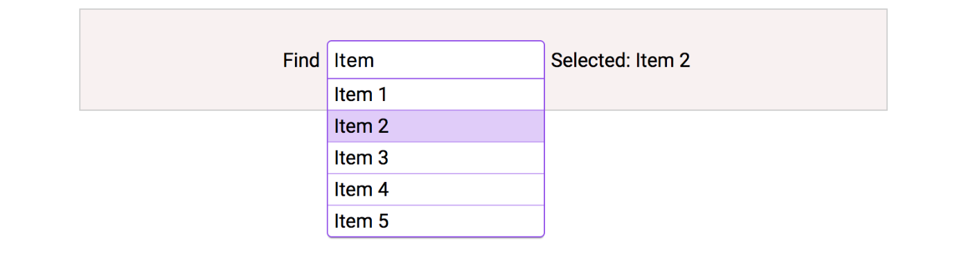

PDF Mastering React: React functions : componentWillReceiveProps

TODO <https://reactjs.org/docs/hello-world.html>

https://reactjs.org/docs/portals.html

TO

react form : <https://reactjs.org/docs/forms.html>

TODO Adv Guide <https://reactjs.org/docs/thinking-in-react.html#step-1-break-the-ui-into-a-component-hierarchy>

react redux form tutorial

TODO redux-form package

//import {Field, FieldArray, reduxForm } from 'redux-form'

//import { Field } from 'react-redux-form';

// Ali TODO redux-form package

<https://stackoverflow.com/questions/43600649/material-ui-redux-from-select-with-dynamic-options>

Rech selectfield <MenuItem react redux

TODO A highly scalable, offline-first foundation with the best developer experience and a focus on performance and best practices. [https://www.reactboilerplate.com](https://www.reactboilerplate.com/)

[react](https://github.com/topics/react)[react-boilerplate](https://github.com/topics/react-boilerplate)[redux](https://github.com/topics/redux)[redux-saga](https://github.com/topics/redux-saga)[webpack2](https://github.com/topics/webpack2)[offline-first](https://github.com/topics/offline-first)[scaffolding](https://github.com/topics/scaffolding)[i18n](https://github.com/topics/i18n)[styled-components](https://github.com/topics/styled-components)

<https://github.com/react-boilerplate/react-boilerplate/tree/master/docs>

<https://github.com/enkidevs/react-search-input>

https://www.npmjs.com/package/react-tags-searchbox

TODO

November 28, 2017

React v16.2.0

Fragments ?

[CodePen](https://codepen.io/reactjs/pen/VrEbjE?editors=1000) Editor :

Formation Samir : temps ?

Envir. Teh :

### Outils : [**Redux DevTools**](https://chrome.google.com/webstore/detail/redux-devtools/lmhkpmbekcpmknklioeibfkpmmfibljd?hl=fr)**(ext chrome)**